*LAB # 01*

INTRODUCTION

# *OBJECTIVE:*

*To become familiar with the Python Programming by using an Integrated Development Environment*

Class task

**Code:**

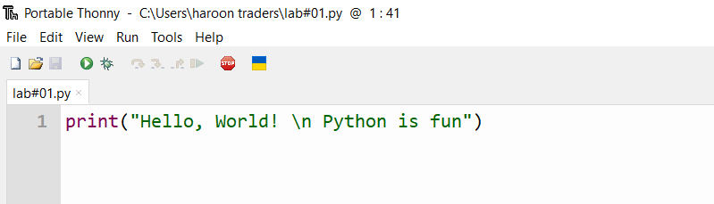

**Output:**

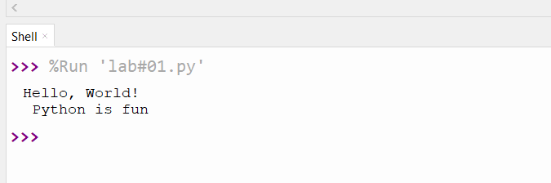

HOME task

**EXERCISE**

1. *Create a file named lab1.py. Write the following code in the file. Execute it and show the output****. (You can use the Snipping Tool to take a snapshot of your output window).***
2. *Code*:

|  |
| --- |
| # My first program  print("\nWelcome in the world of programming!") |

**PERFORMANCE:**

**Code:**

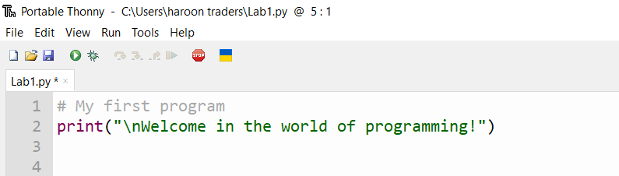

**Output:**

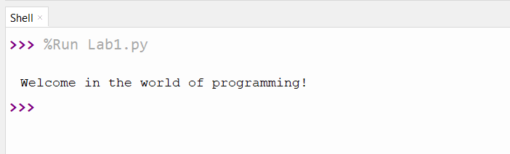

1. *Code:*

|  |
| --- |
| #My second program  print("Welcome in the\n ")  print("world of programming! ") |

**PERFORMANCE:**

**Code:**

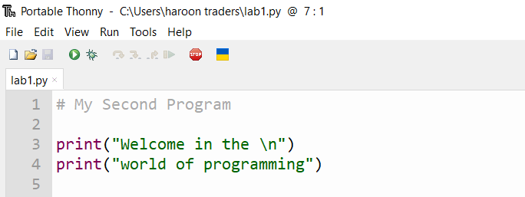

**Output:**

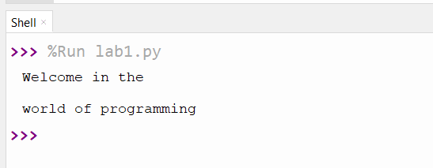

1. *Write a program in Python language that prints your bio-data on the screen. Show your program and its output*

**PERFORMANCE:**

**Code:**

1. *Using simple* ***print*** *function:*

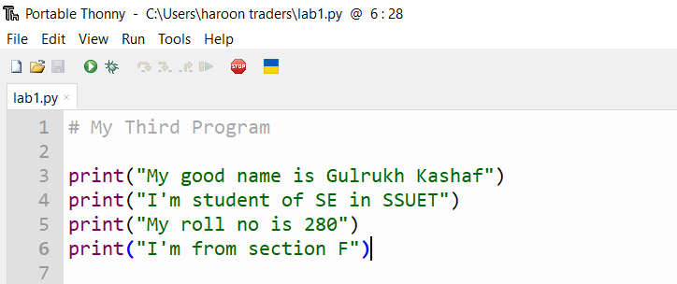

**Output:**

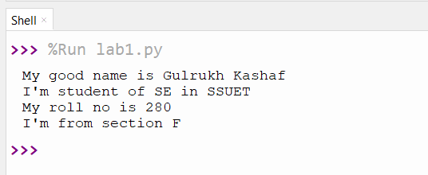

1. *Using* ***print*** *function with* ***\n****:*

**Code:**

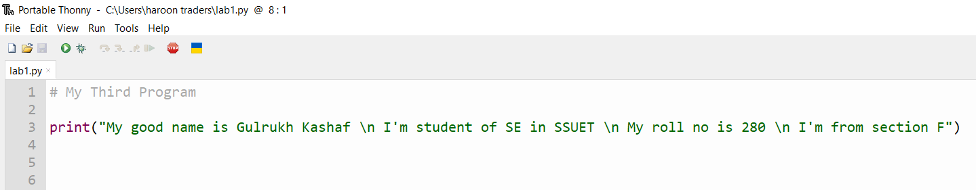

**Output:**

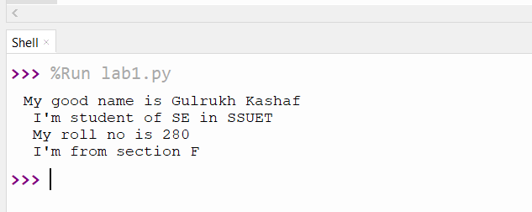

1. *Using* ***print*** *function with* ***variables***

**Code:**

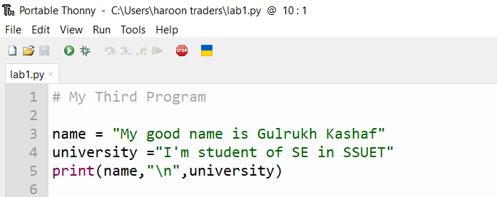

**Output:**

